Are GMO’s Predictions Prescient?
Using them to predict Vanguard’s Mutual Fund Returns

Edward Tower

Economics Department, Duke University, Durham, NC 27708
USA
&
Chulalongkorn University, Bangkok, Thailand

Prepared for the Bogleheads 9 meeting in Philadelphia, October 2010.

tower@econ.duke.edu
919-660-1818

October 2010 (initial version January 2007)

Abstract

Each month, GMO publishes on the web its predictions of the real rate of return for various asset styles over the next seven years. Its web library retains its quarterly predictions, dating back to the end of the second quarter of 2000. This inquiry explores whether they predict the performance of the Vanguard mutual funds that invest in these styles?

1. Introduction

Each month, GMO publishes on the web its predictions of the real rate of return for various asset styles over the next seven years. Its web library also retains its quarterly predictions, dating back to the end of the second quarter of 2000. The GMO web site (http://www.GMO.com) has been the subject of several recent threads of conversation on the Bogleheads Investment Forum. This inquiry asks whether these predictions are useful guides for asset selection. It compares the predictions with the performance of the Vanguard mutual funds that invest in these styles in order to determine whether these predictions serve as useful guides for Vanguard investors. Throughout, all returns are adjusted for inflation, so all returns are real.

2. What I did

The early quarters of the GMO web site predicted ten year returns. Later the web site shifted to seven year returns. Early on only a few asset styles were predicted. Subsequently, GMO incorporated additional styles. I focus on the styles which GMO provided predictions for over the entire period, and which correspond to mutual funds available to Vanguard investors.

The five GMO equity classes are U.S. Large Cap, U.S. Small Cap, International Large Cap, International Small Cap, and Emerging Markets. The corresponding Vanguard mutual funds are 500 Index, VFINX; Small Cap Index, NAESX; Developed Markets Index, VDMIX; International Explorer, VINEX; and Emerging Markets Index, VEIEX.

The three GMO bond classes are intermediate U.S. government bonds, VBIIX, vfitx U.S. inflation protected securities, and U.S. short term treasury bonds. The corresponding Vanguard funds are Intermediate Bond Index Fund, Inflation Protected Securities Fund, VIPSX; and Short-Term Treasury Fund, VFISX.

I gathered GMO predictions from the GMO web site and I gathered three month performance statistics and inflation statistics from the Morningstar Principia Pro disks. Since GMO produces its predictions in January, April, July, and October, I assumed that Vanguard investors allocated their funds at the first business day of the month following the release of the predictions: February, May, August, and November.

I calculated real quarterly returns for the Vanguard funds: February-April, May-July, August - October, November - January.

For the equity funds, I constructed five sequences. The first ranked sequence assumes that the investor invests in the equity class with the highest return prediction from GMO. The second ranked sequence assumes that the investor invests in the equity class with the second highest return prediction from GMO and so forth. I did the same for the three bond styles, and I did the same for all asset classes lumped together.

The predicted GMO returns were constructed by converting the GMO predicted returns to quarterly returns. The quarterly return is given by
(1+predicted annual return)^{.25} -1. The GMO average return for each sequence is the rate of return on what an investor would have accumulated on July 31, 2010 with a start date of July 1, 2000 if his real return had been that predicted by GMO. To reckon with investment costs, I subtracted the expense ratio, converted to a quarterly basis, for the corresponding Vanguard investment class (non-Admiral class) mutual fund.

The realized returns are those of the corresponding mutual funds.

3. Results

Exhibit 1 shows the predicted and realized returns for the equity funds and the bond funds. The predicted returns are adjusted by expense ratios. The correlation between the predicted and realized returns for all assets is 0.828. For equities it is 0.954. For bonds it is 0.959. These are down from the values of June 2008. The ranking of predicted and realized returns are identical for four out of five equity funds. In 3 out of 5 equity sequences GMO was too optimistic, with predicted return exceeding realized return. In all three bond sequences GMO was too pessimistic.

Exhibit 2 is the same graph except the 8 asset classes are obtained by sorting the stock and bond funds together. Here the correlation falls to 0.677. In 5 cases the predictions are too pessimistic and in 3 they are two optimistic. It is not surprising that when all the assets are lumped together the correlation is smaller. Bigger samples yield smaller correlations and different forces influence stocks and bonds.

Exhibit 3 graphs the returns discussed in Exhibits 1 and 2, and serves to assess the closeness of fit of the realized returns to the predicted returns for the three sequences. Ten points lie above the diagonal, and six lie below it. This indicates that GMO has been slightly too pessimistic over the period.

Exhibit 4 graphs the cumulative equity values in real dollars, starting with one dollar, through time. Exhibit 5 does the same for bonds. E1 and B1 denote the # 1 ranked equity sequence and #1 ranked bond sequence respectively, with lower ranked equity and bond sequences denoted by E2 through E5 and B2 through B3. Exhibit 4 shows the substantial cumulative losses suffered by the owners of these funds through the end of 2002 and beginning in 2007. It also shows that the GMO most highly ranked style combination did not dominate the others until the beginning of 2002, suggesting limits to the trust one should put in the GMO predictions as a tool for short-run prediction.

In exhibits 4 through 9 brighter colors denote the bond and equity classes that GMO predicted to perform best, and darker colors denote the classes that GMO predicted to perform worst.

Exhibit 5 graphs the cumulative bond values through time. It shows that from the middle of 2002 onward, except for late 2008 and early 2009, the bonds predicted to do better had a higher cumulative real return. Throughout the period, the bond fund predicted to do worst does worst.

Exhibit 6 does the same as Exhibits 4 and 5, except for equity and bond funds lumped together. It is the dynamic version of exhibit 2. R1 is the top ranked asset class, R2 the second ranked asset class, and so forth. Surprisingly, the best performing asset class is the one ranked number 4.

Exhibit 7 replicates Exhibit 4, except that the vertical axis is presented in log scale and the end point is 1$ for all the asset classes, so it shows how many real dollars one would have had to invest in each equity class to end up with a dollar. This presentation is useful because the real rate of return between two points is proportional to the slope of the curves. Since mid-2007 predictions have been inaccurate. Over the entire period they have been quite accurate.

Exhibit 8 replicates Exhibit 5, with the uniform end point of 1, as in Exhibit 7. The bond fund predicted to do worst, consistently does so. The other two perform similarly. The real return on all of the bond funds has been positive.

Exhibit 9 reproduces Exhibit 6 in simplified form and with the uniform end point of $1. I divided the eight asset classes into two equally weighted portfolios, one with assets ranked 1-4 and one with assets ranked 5-8. The former out-returned the latter over the entire period, but under-returned dramatically from the spring of 2008 and dropped precipitously to the beginning of 2009.

- Conclusion

The GMO predictions are prescient enough to be a useful input into investment decisions. Investors should be grateful to GMO for providing them at no charge.

Specifically,
- The correlation between the GMO predicted returns and the Vanguard realized returns for equities, bonds, and all assets taken together are 0.954, 0.959 and 0.677 respectively. These are average geometric returns from The end of July 2000 through the end of July 2010. They are for asset classes ranked by predictions. Thus, asset classes predicted to have high returns do have high returns. (Exhibits 1 and 2).
- The ranking of bond returns by predictions and realizations is identical, for stocks is almost identical (with one outlier), and all assets taken together is less good (with two outliers). (Exhibit 3).
- An equally weighted portfolio of the asset classes with the top four predictions returns better than a portfolio of the asset classes with the bottom four predictions, but the former suffered a greater loss in the 2007-9 meltdown (Exhibit 9).

I am grateful to William J. Bernstein for looking at the calculations presented in the January 2007 version of this paper. His reaction was “in 2000, the valuations of different equity classes was about as widely spread out as historically been the case, so predictions based on them were most likely to be correct.” He added that now [January 2007], valuations are a lot more narrowly spread, so style picking is not going to be so successful going forward. The GMO predictions support this. In June 2000 the spread between the highest and lowest GMO equity class predictions was 10.6% per year. On October 31, 2009 the spread of the GMO predictions for the same five equity classes was only 3.4% per year. Similarly the bond spread had fallen from 1.9% to 1.3%. Currently (in October 2010) the spreads are 5.3% and 1.1%

References

Tower, Edward (2010). Strategic Asset Allocation in Practice: Using Vanguard Funds to Clone GMO’s Benchmark-Free Allocation Fund. Duke Working Paper.

Exhibit 1. GMO Predicted Real Returns, adjusted by expense ratios, and Vanguard Realized Real Returns
7/31/2000-7/31/2010
(% per year)
Asset | GMO prediction | Vanguard Result
Equity Rank 1 | 5.77 | 8.00
Equity Rank 2 | 3.51 | 4.11
Equity Rank 3 | 2.47 | 1.14
Equity Rank 4 | 0.61 | -2.51
Equity Rank 5 | -0.60 | -1.26
Bond Rank 1 | 2.01 | 5.01
Bond Rank 2 | 1.64 | 4.61
Bond Rank 3 | 1.05 | 1.62
Correlation for all assets |  | 0.828
Correlation for equities |  | 0.954
Correlation for bonds |  | 0.959

Exhibit 2. GMO Predicted Real Returns, adjusted by expense ratios, and Vanguard Realized Real Returns, all assets combined 7/31/2000-7/31/2010 (%/year)
Asset | GMO prediction | Vanguard result
Rank 1 | 5.99 | 5.85
Rank 2 | 3.94 | 5.14
Rank 3 | 3.22 | 3.25
Rank 4 | 2.16 | 9.42
Rank 5 | 1.71 | 2.72
Rank 6 | 0.79 | -2.93
Rank 7 | -0.22 | 1.55
Rank 8 | -1.12 | -3.44
Correlation |  | 0.677

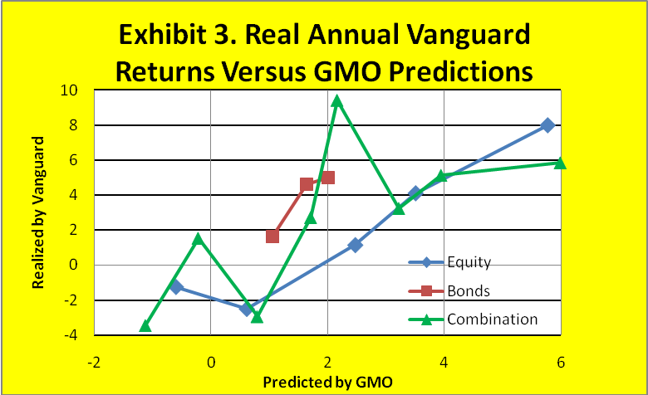
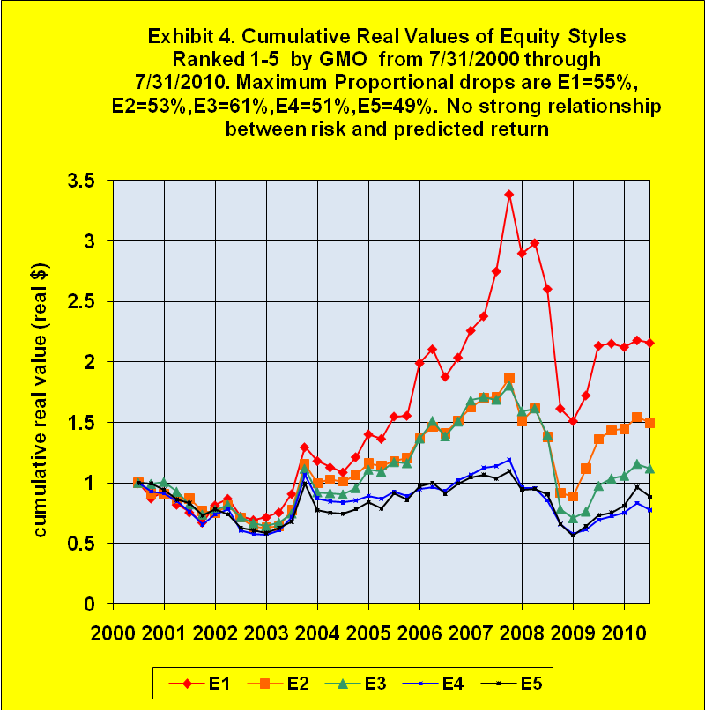

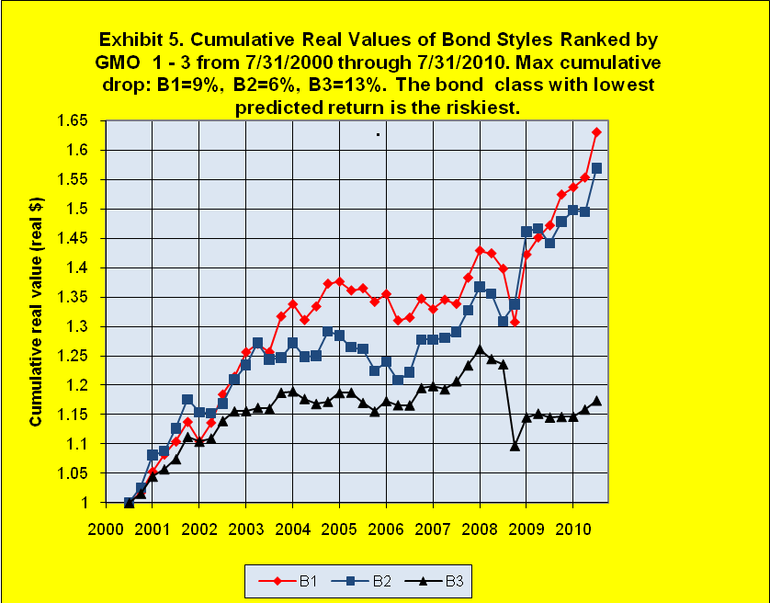
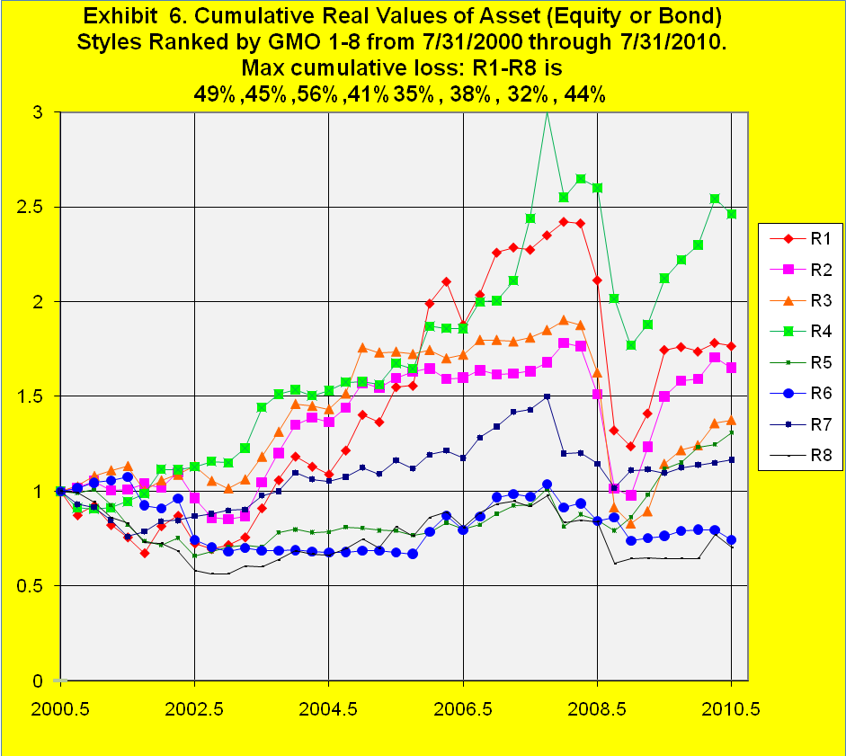

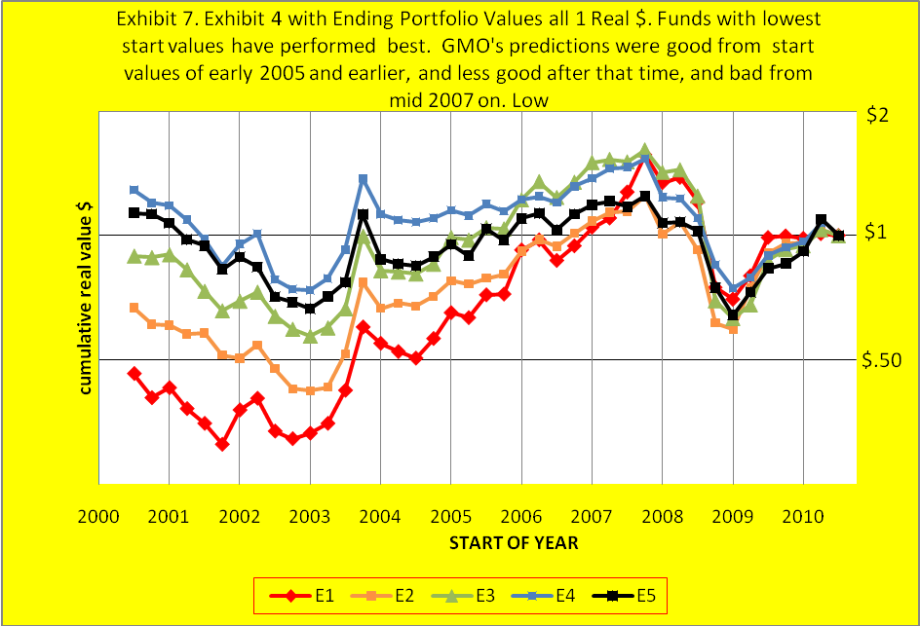

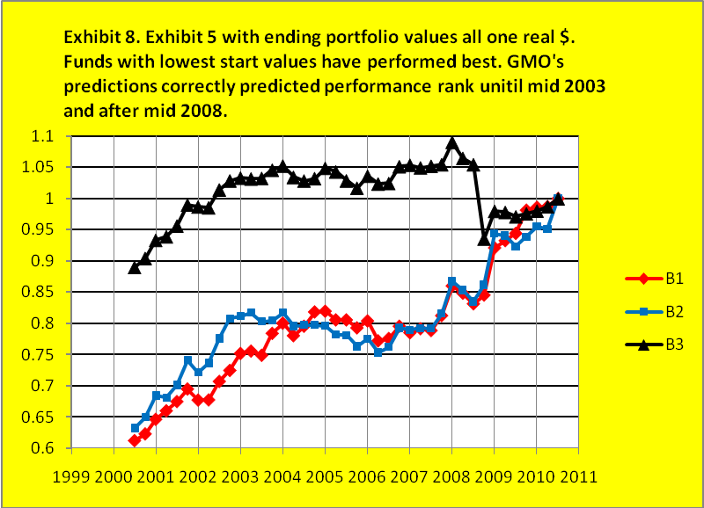

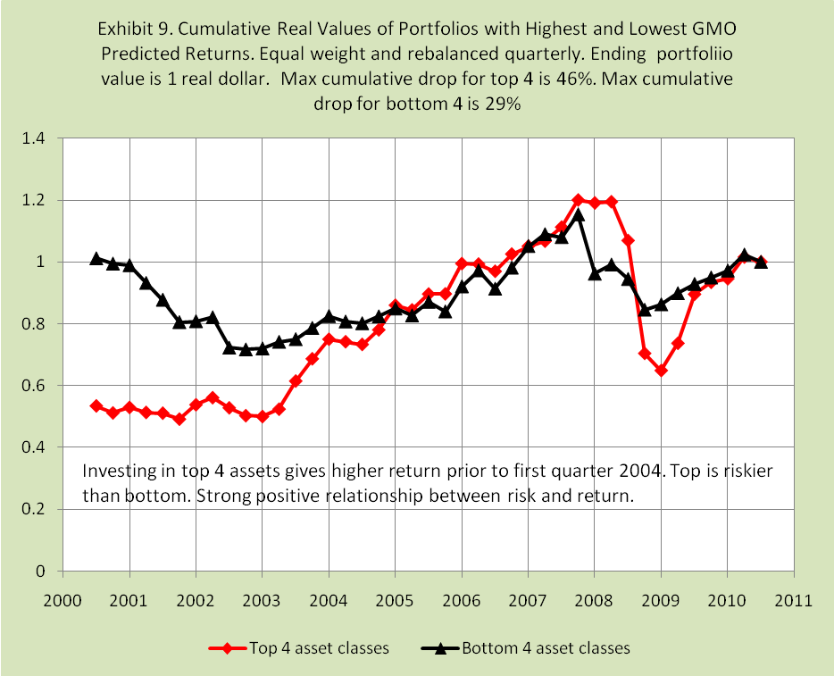

An earlier version of this paper was written in January 2007. Some readers of it have expressed skepticism. Some have argued that the GMO predictions are for long periods and do not apply for short periods. One has argued that for investors to depart from constant weights for various asset classes is dangerous. One noted that GMO sells a mutual fund based on its asset class projections, GMO Benchmark Free Allocation III (GBMFX), a fund which was established only in July 2003. As I discuss in Tower (2010), the asset allocation in that fund does not appear to follow the GMO asset class return predictions. The methodology behind the GMO predictions is discussed in Jeremy Grantham’s letter of July 2004, available on the same web site. It is also discussed in Ben Inker, “ GMO Seven Year Asset Class Forecasts Methodology and Assumptions,” https://www.gmo.com/America/CMSAttachmentDownload?target=JUBRxi51IIDCY4K1SGj6auCUOZPl0zyOaitc3OmyzuXzmEHVf37Hy4BGMPc20qoncmn2hH2AFKOeIDWEiACi%2f7kkqo8%2fq0wgo%2bG8MspC171fWNKrEsWIXk45F4Hvqsct Thanks for helpful comments go to Bill Bernstein, John Seater, and the participants in the Vanguard Diehards thread # 56771 on the Morningstar web page, http://www.morninstar.com.

